FOR VS 2015

Installed [SSDT](https://msdn.microsoft.com/en-us/library/mt204009.aspx). I am still not able to see Integration Services project in new project menu in Visual studio 2015.

<https://msdn.microsoft.com/en-us/library/mt204009.aspx>

Download SQL Server Data Tools (SSDT)

File -> New -> Project …. Templates

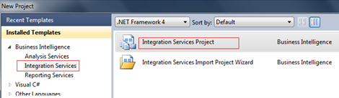

|  |  |
| --- | --- |
|  | As long as SSDT installed properly, it should be under File -> New -> Project... |

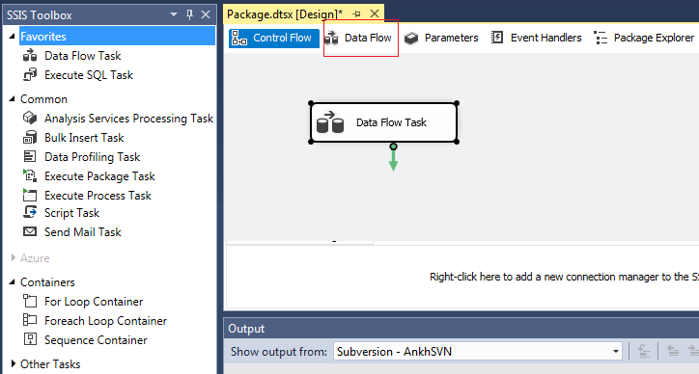

Cuando escoge un Data Flow Task, se escoje Data Flow

